Create Azure Resource
- Go to Google, enter Azure Portal Login in Search bar, and click Enter key.

- Click All resources to create a Resource.
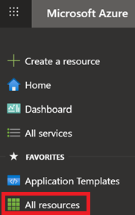
- Click Create button to create a resource.
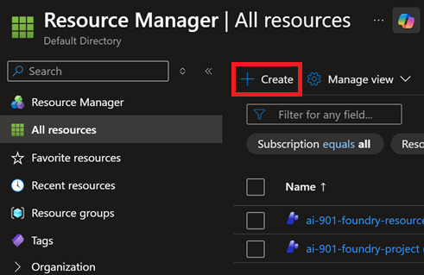
- Enter Microsoft Foundry in Search bar and click Enter key.
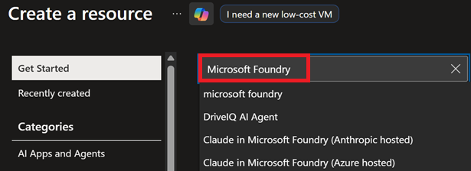
- Locate Microsoft Foundry resource, click Create button, then click Microsoft Foundry button.
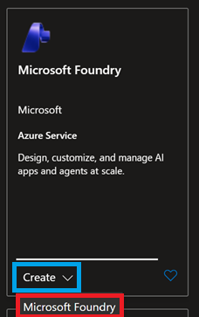
- Do the following:
- Select Subscription.
- Select Resource Group.
- Enter Resource Name.
- Select Region to deploy resource to.
- Enter Project Name.
- Click Review + create button.
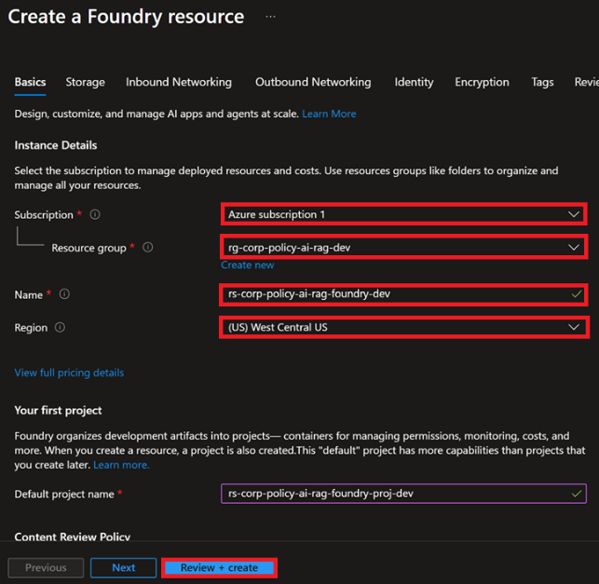
- Click Create button.
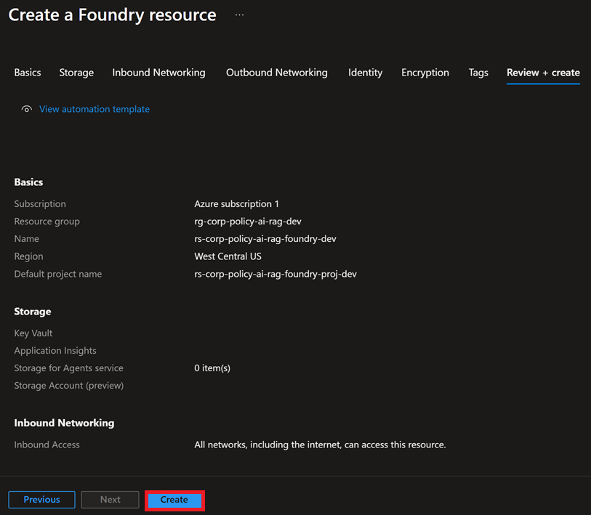
- Click Go to resource button.
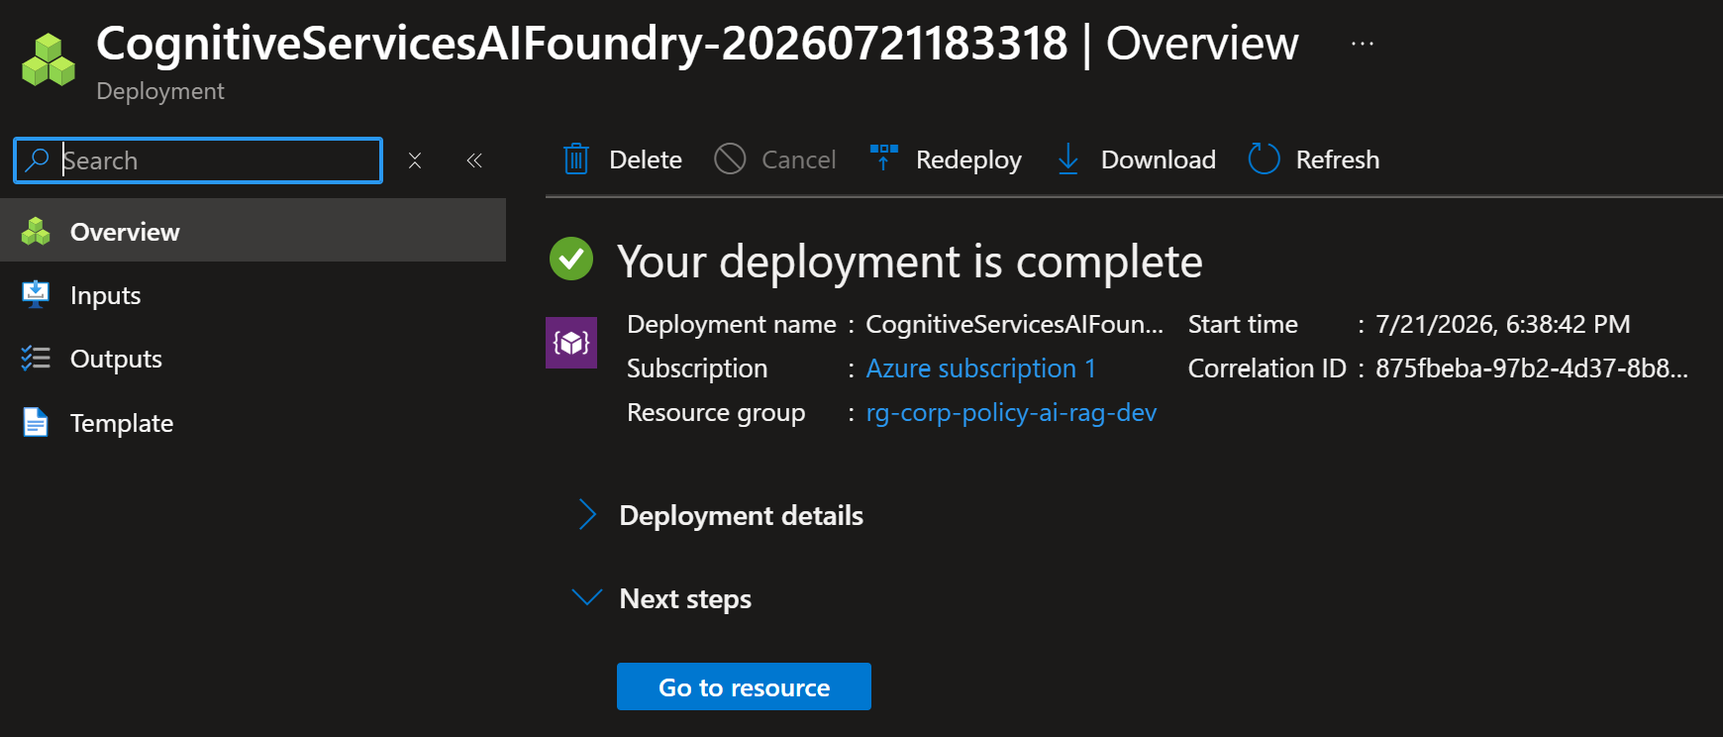

- Click Resource group link.
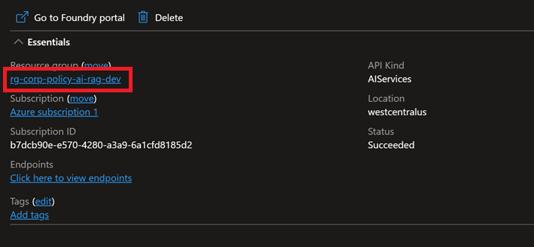
- See newly created Resource Group. Finished.

